**ASSIGNMENT 1**

**WHAT IS THE WRITING PROCESS?**

No writer can generate a perfect draft on the first attempt. Most employ a ***writing process***, in which they begin with **prewriting and invention, then outlining, composing, revising and editing**.

Though the aforementioned might suggest a linear process, it is usually recursive. For instance, you might end up going back to the prewriting phase and do some brainstorming even while writing the actual draft. The general rule of thumb is to invest some time brainstorming and writing a rough outline before writing the essay. Also, save editing for last. Sometimes it may be too difficult to juggle developing your ideas along with attending to grammar so save editing for the very last step.

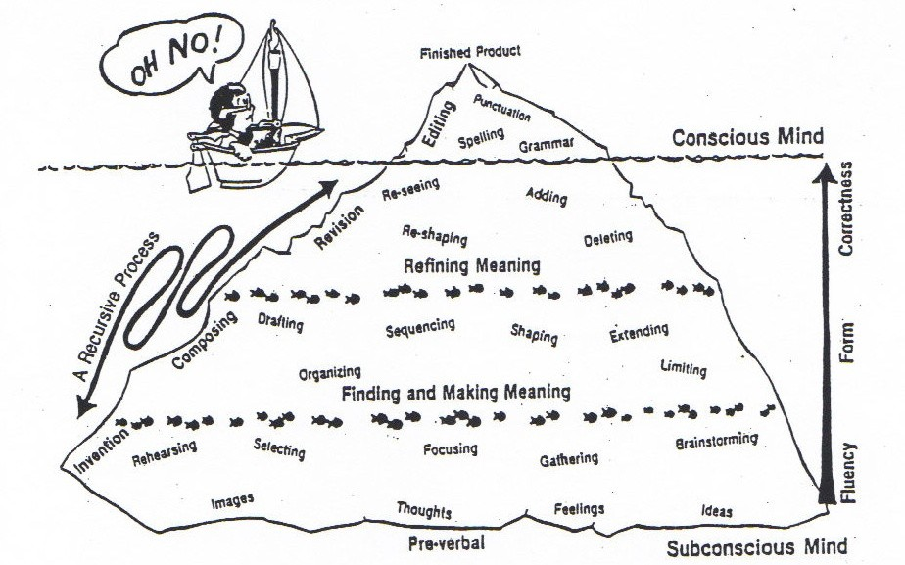

**WRITING AS A PROCESS NOT A PRODUCT*:***

The iceberg diagram gives a visual image of the writing process. Above the water line is the final product your instructor sees, and below the water line are all the less visible yet important steps that went into building a good essay. Unfortunately, many writers “wreck” themselves by just focusing on the final product rather than the process. This can give you writer's block. Also, following a process, rather than last-minute writing, will help you to produce your strongest and best essays.

# WHAT IS PREWRITING?

The prewriting stage is when you begin generating ideas on your topic without focusing too much on organization and correctness. Prewriting allows you to begin creatively and to truly explore the scope and potential of your topic. Also, breaking the writing process down into stages makes it less stressful and more manageable and gives you time to figure out exactly what you want to develop and explore in your paper.

Here are some **successful prewriting strategies:**

Freewriting Brainstorming Journalist Questions Listing Clustering/Mapping

**Now,we will look at the WHAT, WHY and HOW of each of these prewriting strategies.**

**WHAT IS FREEWRITING?**

Freewriting is a technique that helps you generate content for an essay. Freewriting is writing continuously, letting thoughts unselfconsciously flow (often for about 5 to 10 minutes) without regard to spelling, grammar, style etc., and no corrections are made. Because there are no restrictions on structure/format or length, freewriting allows you the freedom to discover what you want to write about without worrying about rules or expectations.

# WHY IS IT IMPORTANT?

* + - It provides you with the raw material to help you start writing an essay.
    - It helps you to bypass your “internal critic” who can make it difficult for you to explore your thoughts and ideas.
    - It gives you confidence in your ability to explore a topic.
    - It helps you develop your own unique writing voice and promote a solid flow, or rhythm, to your sentences.
    - It gives you an easy way to begin any piece of writing and helps you surpass writer’s block.

# HOW DO I DO IT?

Start with a blank piece of paper or blank computer screen. Give yourself a minimum of five minutes of uninterrupted time to free write. Write a few words at the top of the page to get you started and keep you focused, such as the general topic of your essay assignment or a quote from the text that is significant to you. Now begin writing whatever comes into your head when you think about this quote, the topic and/or the assignment that you have been given.

Try to keep writing without stopping, crossing-out, or erasing. Even if what you are writing seems like it isn’t “correct” or “perfect,” keep going. This is the key to freewriting – to write freely! Go for five minutes without stopping. If you have more to say, keep going for as long as you can. Don’t evaluate what you are writing, or you will stop the free flow of thoughts and ideas.

Once you have a page or more of freewriting, read back over it and look for ideas or points that you might include in your essay. Underline or circle sentences or groups of sentences that you especially like and think you may be able to use in your essay. Use your freewriting as a springboard for your thinking about this assignment, directing you toward further reading, research and the writing of the first draft of the essay.

**Freewriting sample**



**EXAMPLE**

**In response to Chapter VII in *Narrative of the Life of Frederick Douglass*, do the following:**

Write a quote, or part of a quote, from the text by Frederick Douglass at the top of a blank piece of paper or a blank computer screen (or your most recently assigned text). For approximately five minutes, write anything and everything that is triggered by the quote.

**Selected quote: “I have often wished myself a beast. I preferred the condition of the meanest reptile to my own. Anything, no matter what, to get rid of thinking!”**

F rede r ick Doug lass has lea rned to read and a f te r he reads a speech by

She r idan , he sees tha t h i s human r igh t s have been taken away by s lave ry .

He began to ha te h i s ens lave r s . He says they a re robbe rs who took A f r icans

f rom t he i r homes and b rough t them to Ame r ica to ens lave them and take away the i r human r igh t s . Once Doug lass can read , h i s th ink ing sk i l l s a re

s t ronge r because he i s exposed to ideas beyond h i s own expe r iences , and

h i s unde r s tand ing o f the opp ress ive na tu re o f s lave ry i s even s t ronge r . He says tha t h i s Mas te r Hugh was r igh t – he fee l s a powe r fu l fee l ing o f d i scon ten tmen t tha t i s so pa in fu l tha t he a lmos t w i shes he we re i l l i te ra te

and d idn ’ t know how to read and th ink . He i s ove rwhe lmed by wha t he rea l izes and says he w i shes a t t imes he was igno ran t because he i s

to rme n ted by the ho r ro r o f s lave ry . I t i s i ron ic because s lave ry i s dehuman iz ing and Doug lass says he a lmos t w i shes he d idn ’ t know wha t he

knows and cou ld s tay igno ran t . Th i s makes me th ink abou t how read ing and th ink ing he lp to l ibe ra te and en la rge ou r m inds , and tha t i s why in many

coun t r ies run by d ic ta to r s the re i s a h igh ra te o f i l l i te racy . I f peop le a re kep t i l l i te ra te , they can be opp ressed mo re eas i ly . Be ing exposed to ideas can p romo te consc iousness , wh ich can lead to ac t ion . F rede r ick

Doug lass was changed fo reve r by h i s ab i l i ty to read , w r i te and th ink abou t h i s s i tua t ion as a s lave . Th i s makes me th ink how a l l o f us a re ens laved

in one way o r ano the r , and tha t by read ing and th ink ing abou t i t , we can f ree ou rse lves .

**Ideas for an essay topic drawn from this example of freewriting:**

* + - How learning to read, write and think about ideas is a liberating experience
    - How anger and discontentment can fuel awareness and action
    - The power of ideas to build consciousness
    - The irony of Frederick Douglass wishing to be a “beast” because of the painful truths he realizes about the dehumanization of slavery

**Freewriting**



**PRACTICE**

**Analyze the following quote from Chapter VII in *Narrative of the Life of Frederick Douglass* (or analyze a quote or aspect of your most recently assigned text). For approximately five minutes, write anything and everything that is triggered by the selected text.**

**Douglass Quote:** “My mistress was, as I have said, a kind and tender-hearted woman; and in the simplicity of her soul she commenced, when I first went to live with her, to treat me as she supposed one human being ought to treat another. In entering upon the duties of a slaveholder, she did not seem to perceive that I sustained to her the relation of a mere chattel, and that for her to treat me as a human being was not only wrong, but dangerously so. Slavery proved as injurious to her as it did to me” (31).

**Free write:**

**WHAT IS BRAINSTORMING?**

Brainstorming is like freewriting in that you write down whatever comes to mind without stopping, but it is different because it looks more like a list of words and phrases than a string of sentences.

# WHY IS IT IMPORTANT?

* + - It is easier to see the main ideas when “boiled down” in a brainstorm
    - It helps you summarize the main concepts in the reading
    - It helps you see the main ideas that captured your interest in the reading
    - It can make complex reading more accessible
    - You can see many choices of paper topics emerging
    - It is fast and easy

# HOW DO I DO IT?

Look back at your freewrite and capture the important concepts into words and phrases. Also, look back at the text and pull out the main ideas and concepts.

**Brainstorming sample**



**EXAMPLE**

Here’s an example of brainstorming in response to Chapter VII in *Narrative of the Life of Frederick Douglass:*

|  |
| --- |
| **forbidden to read and write impressive determination**  **humans treated as beasts bread for knowledge—both feeding**  **depravity of slave owners Christian country?**  **abuse of power rights to freedom**  **slavery turning good people bad emancipation—liberation**  **reading and writing as dangerous slavery as indefensible education and slavery incompatible reading a curse or blessing? fear of rebellion wretched condition—no remedy**  **dehumanization ignorance is bliss?**  **used white boys as teachers building consciousness** |

**Brainstorming**



**PRACTICE**

**In response to the quote from Chapter VII in *Narrative of the Life of Frederick Douglass*****(or your most recently assigned text), look at your freewrite and brainstorm the important concepts into words and phrases and then add to it.**

|  |
| --- |
|  |

**WHAT ARE JOURNALIST QUESTIONS?**

“Journalist questions” are the “5Ws and the 1H”**—**who, what, when, where, and especially why and how. The who, what, when, and where are relevant to summaries while the how and why prompt you to examine the “so what?!” Use ideas from the text, your freewrite and your brainstorm and form them into questions. Through answering these questions, you can discover interesting information that you can use for writing.

**WHY ARE THEY IMPORTANT?**

You may be asked to write about a topic or book, in which case you will need a means to generate the questions that most intrigue you. While who, what, when, and where questions are an effective means of gauging your comprehension, the why and how questions lend themselves to analysis, which is integral to any essay. After generating a list of questions, answer them. You may discover that a question generates multiple answers, some of them contradictory. Such controversy is often ripe for exploration and can lead to thought-provoking interpretations of texts. Answering complex questions is a way to form thesis statements.

#### HOW DO I CREATE THEM?

Look back at the text and then at your prewriting and think of the questions that were raised for you, or circle concepts or ideas you would like to know more about, and then form questions around them.

**Journalist Questions sample**



**EXAMPLE**

Here are some examples of the journalist questions using Douglass:

***Who were the main advocates of slavery?***

***What were the writings that most affected Douglass?***

***When was the period in which Douglass lived?***

***Where was slavery the most prevalent?***

***Why was reading considered such a threat to slave-owners?***

***How did the slave-owners maintain control over human beings for so long?***

**Creating Journalist Questions**



**PRACTICE**

In response to Chapter VII in *Narrative of the Life of Frederick Douglass* (or your most recently assigned text), create questions:

***Who***

***What***

***When***

***Where***

***Why***

***How***

**WHAT IS LISTING?**

Generating ideas on a topic through freewriting, brainstorming, and creating questions has a purposeful messiness to it. It is the time to let your creativity run riot and to push your thinking in new and sometimes unexpected directions. Once you have generated a lot of material on your topic, however, it is time to take stock and begin to narrow down and organize your ideas as you move towards writing a focused essay. Listing helps you to **select certain ideas** and **organize** them by grouping related concepts together. This is the most informal kind of outline in which you jot down your main supporting points and possible evidence and analysis. This kind of outline is for you only, and you don’t need to worry about making it more comprehensive if it does the job for you. Many students find this kind of outline helpful in taking timed essay exams because it is brief, and it doesn’t take much time to produce.

# WHY IS IT IMPORTANT?

When you are just beginning to write an essay, rather than making a formal outline, you can make a list. A list is a very user-friendly technique because you don’t yet need to craft full sentences but instead select your most promising ideas and start to look for connections between them. Listing is important because it takes all the free-form ideas you generated and helps you to see how you could narrow and focus the material to present a convincing, logical argument.

# HOW DO I DO IT?

Start with a blank piece of paper or computer screen. Stay focused by keeping your essay assignment and/or the annotated text you are analyzing next to you. Begin making a list of everything you think you would like to write about to fulfill the assignment or to respond to in the text. Use keywords or phrases; it’s not necessary to write in complete sentences when listing. Using a bullet-list format is helpful.

Once you have made your list, go back and organize it into logical units; for example, you can use a numbering system to indicate what you want to include in your introductory paragraph, your body paragraphs and your conclusion. Arrange the ideas in the body paragraphs into a logical order. To illustrate your body paragraph points, you can add quotes, examples, or information to further research. You may find it useful to make a second, more detailed list or you may decide to turn your list, once it is full enough, into an outline.

**Listing sample**



**EXAMPLE**

Here are some examples of listing using Douglass and the ideas that came from the stages of freewriting, journalist questions, and brainstorming:

**IDEA: Slavery harmed the mistress as much as it did the slaves**

* + - * the mistress changed – “tender-hearted” to mean-spirited
      * she took the newspaper away from him so he couldn’t read

**IDEA: Learning to read changed Douglass forever — became intolerant of slavery**

* + - * read Sheridan and saw good arguments against slavery
      * saw slave owners as robbers stealing his people from Africa
      * he came to hate (“abhor and detest”) his enslavers

**IDEA: Reading as dangerous**

* + - * slave masters feared rebellion
      * reading caused Douglass awareness but also despair
      * “silver trump of freedom had roused my soul to eternal wakefulness”

**IDEA: Denial of literacy is still used to control people**

* + - * poor urban neighborhoods with subpar schools and lack of supplies
      * women in certain places in the middle east not allowed to learn to read and write

**Listing**



**PRACTICE**

**In response to Chapter VII in *Narrative of the Life of Frederick Douglass* (or your most recently assigned text), do the following:**

Make a list of main points in the reading. Leave space under each main point for 2-3 examples that support the idea. You can put the examples in after you’ve come up with at least 3-5 main points. Afterwards, look at how the ideas connect to one another to form a possible unifying thesis or argument:

# WHAT IS CLUSTERING/MAPPING?

Clustering, also known as mapping, is like listing in that you narrow down and begin to organize your ideas. Cluster/mapping provides a mental picture of the ideas you generate and how they connect to each other. Where you place ideas on the page shows their relationship to each other. Ideas placed closer to the middle are the overarching key concepts that unify seemingly disparate ideas and details.

# WHY IS IT IMPORTANT?

* + - It works particularly well for visual learners.
    - It helps you to see the most important ideas.
    - It helps you to see how ideas are related.
    - It helps you organize your ideas.
    - It helps you start to see potential paragraphs forming.

# HOW DO I DO IT?

To create a cluster, first write your topic or question in the middle of the page and draw a large circle around it. Then in medium circles, write the supporting points that respond to the writing task, drawing lines linking each to the main center circle. Then, in small circles, write the evidence and analysis that illustrate each supporting point, drawing lines that link each to the appropriate supporting point. You can add additional levels of smaller circles as you provide more specific clarifying details.

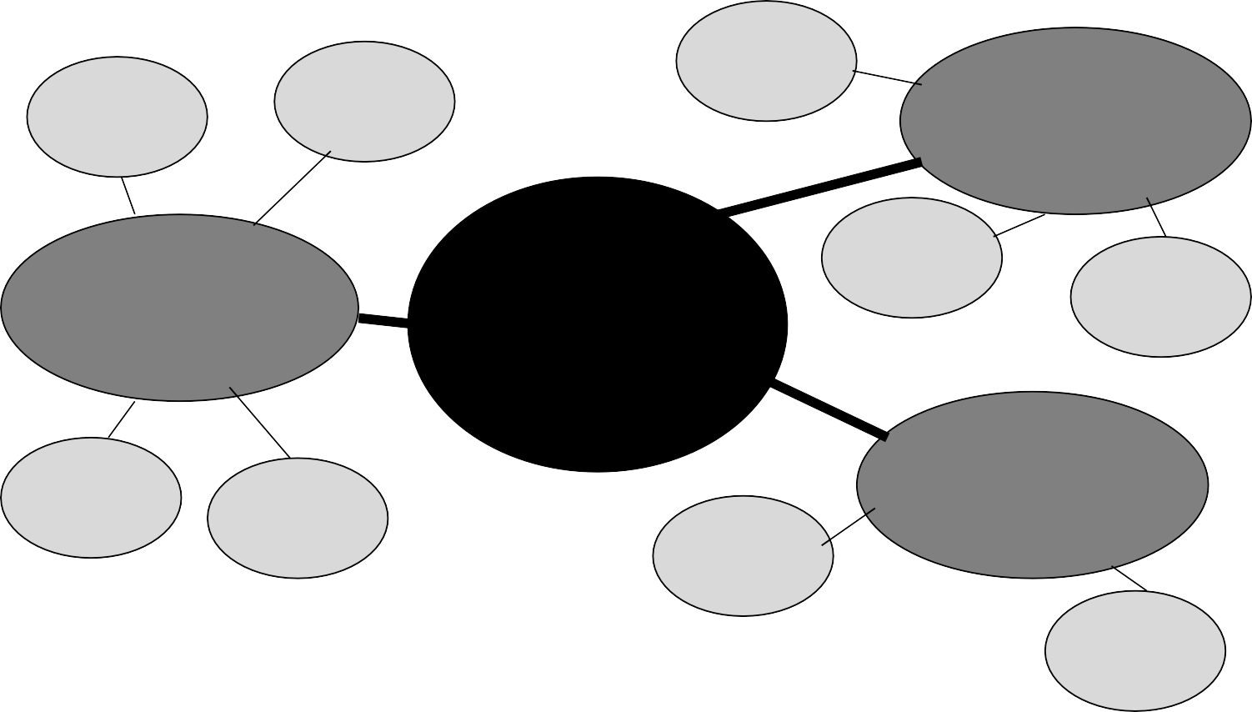

Evidence/ Analysis

Evidence/ Analysis

Evidence/ Analysis

**SUPPORTING POINT**

**SUPPORTING POINT**

***TOPIC OR***

***QUESTION***

Evidence/ Analysis

Evidence/ Analysis

Evidence/ Analysis

Evidence/ Analysis

**SUPPORTING POINT**

Evidence/ Analysis

Evidence/ Analysis

Skyline English 121

Fear of rebellion

**Cluster**

Educated people harder to subjugate



**EXAMPLE**

Douglass envied other slaves their stupidity

**Douglass was**

Sees how he is trapped

Awareness through reading brought

Mr. and Mrs. Hugh forbid Douglass becoming literate

**tortured but also freed by learning to read**

Douglass despair

**Denied slaves education to control them**

States passed laws making it illegal to teach slaves to read or write

Can’t read, can’t know

rights

Can’t read

history to get a perspective of what is fair

***Topic: reading and writing as dangerous***

Also liberated him and he turned anger into action

He escaped slavery and went north

He became a lifelong activist

Fought for rights of blacks

Fought for rights of women

Muktar Mai, like other rural Pakistani women, not allowed an education

**Others also denied education**

Kids in inner- city school in

U.S. denied an equal education

Victimized and didn’t know rights



Became educated and an activist

Schools underfunded and understaffed

High dropout rates

**Clustering**



**PRACTICE**

**In response to Chapter VII in *Narrative of the Life of Frederick Douglass* (or your most recently assigned text), create a cluster/map:**

**Main topic or question:**